Windows client Screen shots (8/15/12)

The program runs automatically at the end of the installation process. The user sees the following window:

PageHome: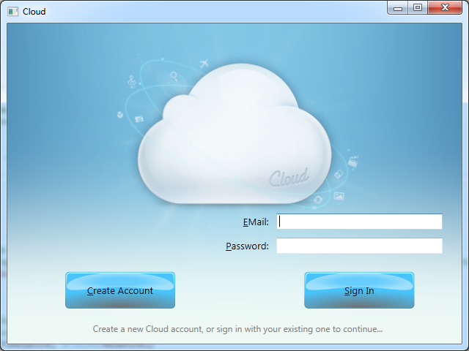

If the user has an account already, type the Email address and password and click Sign In. The next page will be PageSelectStorageSize (later). If the user clicks Create Account the next window will appear:

PageCreateNewAccount: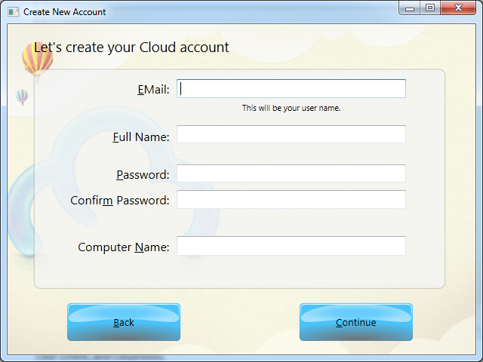

The Back button will return to PageHome. The Continue button moves to the next page:

PageSelectStorageSize: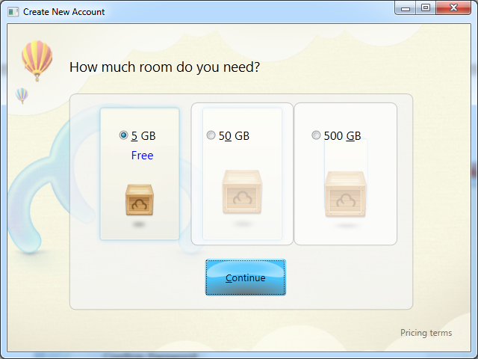

Choose your storage size and click Continue to arrive at the next page:

PageSetupSelector: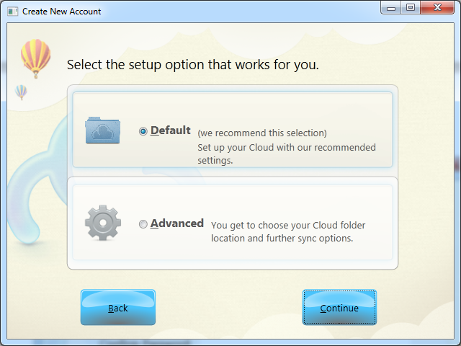

The Back button will go back to PageSelectStorageSize. Select Advanced and click Continue to show the next page. Selecting Default and clicking Continue will go to PageTour1.

PageFolderSelection: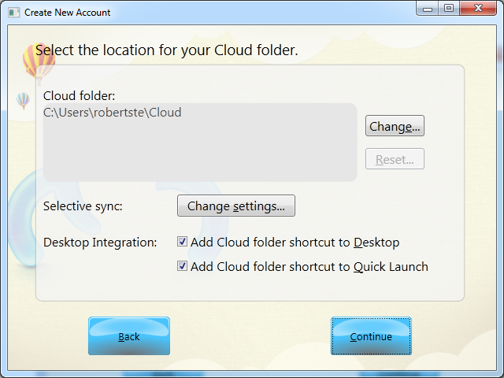

Click “Change:…” to see a common dialog box. In this case, it is the prompt that informs the user about what will happen, and asks whether to continue. Click Yes to see the folder selection dialog:

MessageBox: Do you wish to change your Cloud Folder?: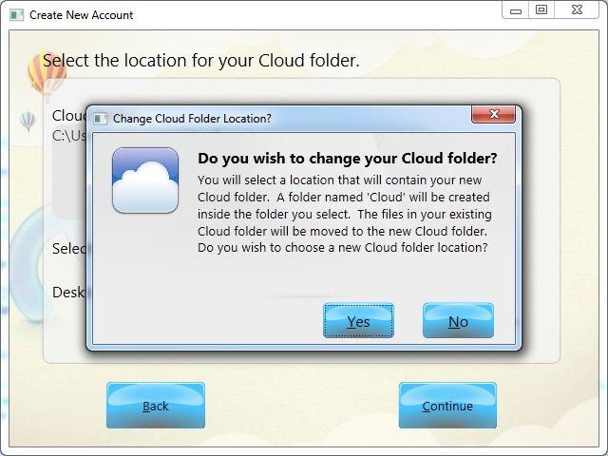

Click Yes to see the next folder selection dialog.

Standard Windows Folder Selection dialog. We don’t have any choice about this one. The only change we can make is to change the text in blue.

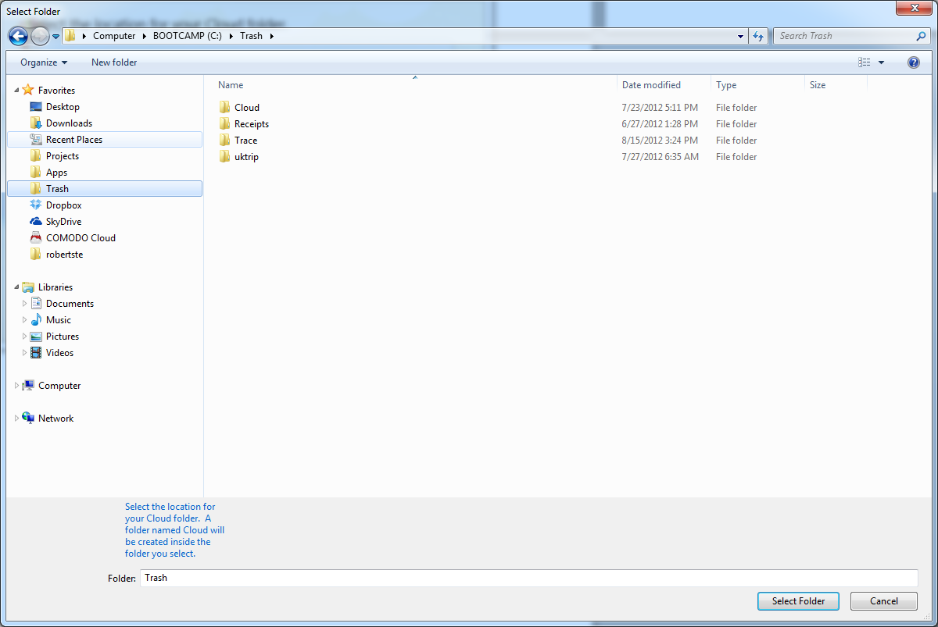

Select a new location to hold your Cloud folder (in this case “Trash”) and click Select Folder. This returns to the PageFolderSelection page:

PageFolderSelection: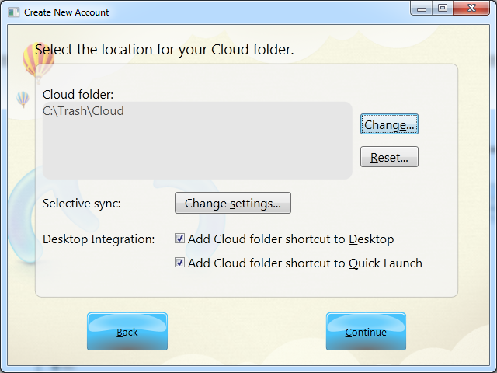

Notice the changed Cloud folder location. The Reset button is now active. Clicking the Reset button will reset the Cloud folder location to the default. The Selective sync: Change settings button does nothing at the moment. The Desktop Integration choices will probably be removed or changed. Click Back to return to PageSetupSelector. Click Continue to go to the next page:

PageTourAdvancedEnd: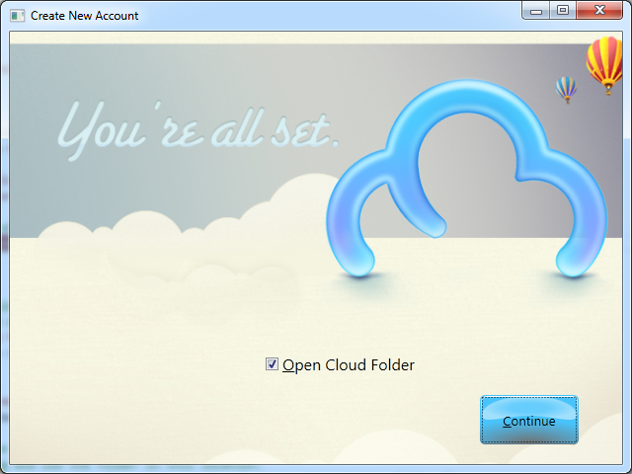

This is last setup page in the advanced mode. Checking “Open Cloud Folder” will open the Cloud folder in Windows Explorer. Clicking Continue will remove this window and install the Cloud icon in the system tray. This window is animated down to the system tray and a welcome tooltip is shown over the system tray:

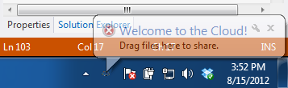

Back on PageSetupSelector: If the user selected “Default” and clicked the Continue button the first page of the tour is shown.

PageTour1: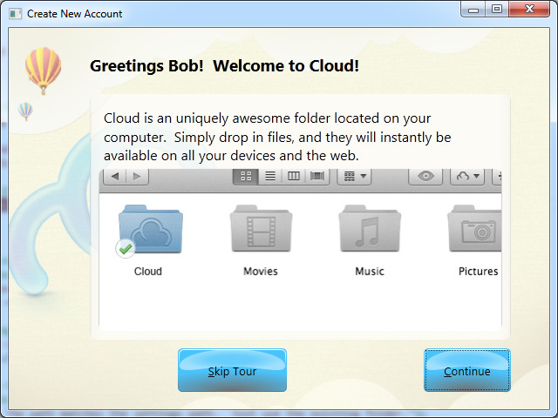

This is the first page of the tour. Clicking Skip Tour presents the final page of the tour (PageTour5), shown later. Clicking Continue shows the next page of the tour:

PageTour2: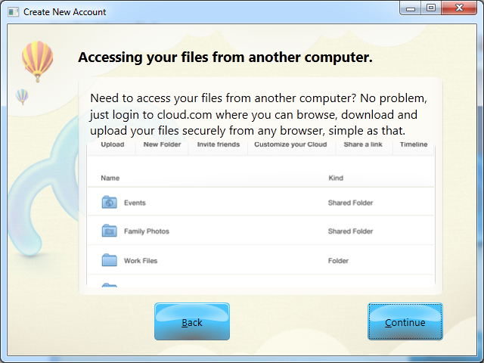

Clicking Back returns to PageTour1. Clicking Continue goes to the next page. Here are the rest of the tour pages:

PageTour3: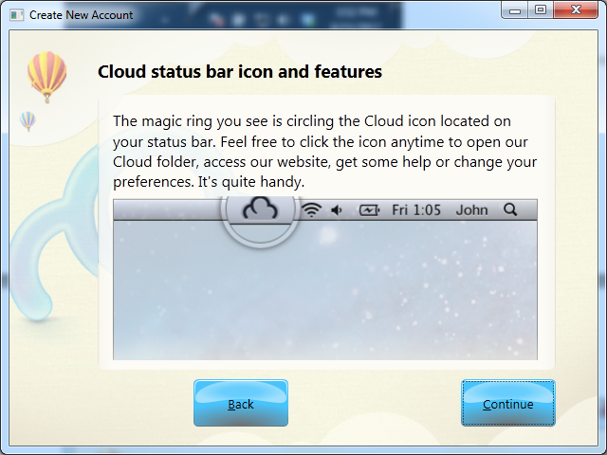

PageTour4: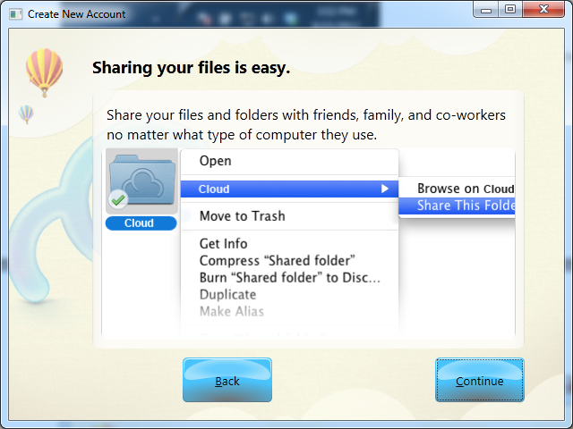

PageTour5: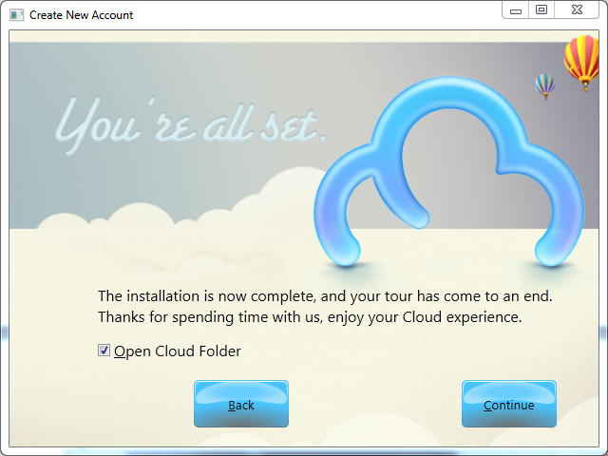

This is the last page of the Default setup. Checking Open Cloud Folder will open the Cloud folder in Windows Explorer:

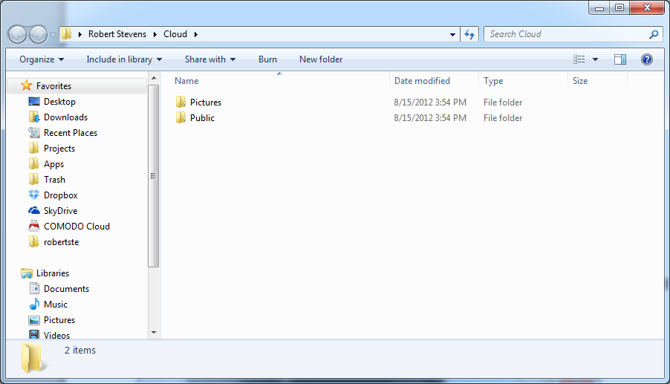

Clicking Continue on the PageTour5 page will remove the tour window and it will animate down to the System tray and display a welcome tooltip as before. It will also install the application represented by an icon in the system tray:

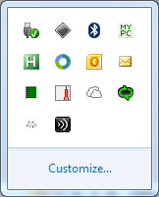

Currently, it’s the very small cloud in the lower left corner. Right-clicking the systray icon will bring up a context menu. Currently it looks like this:

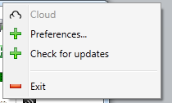

Clicking Exit will exit the application. Clicking Check for updates will show the following page (with the appropriate message of course):

DialogCheckForUpdates: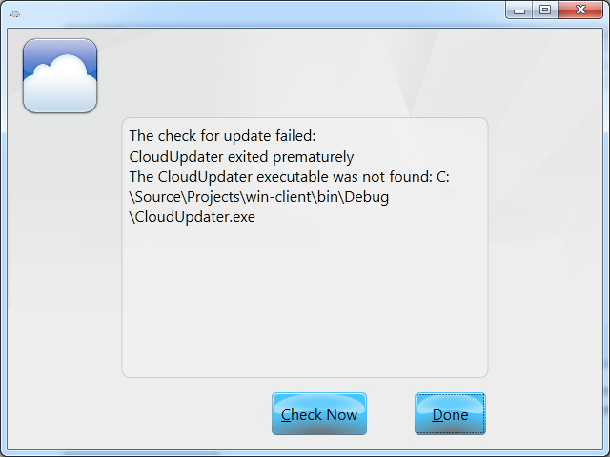

Clicking Check Now will check for an update again. Clicking Done will exit this window.

Clicking “Preferences…” on the systray context menu will bring up the Preferences page. This page will animate up out of the system tray.

PagePreferences (outer chrome), FramePreferencesGeneral (inner content):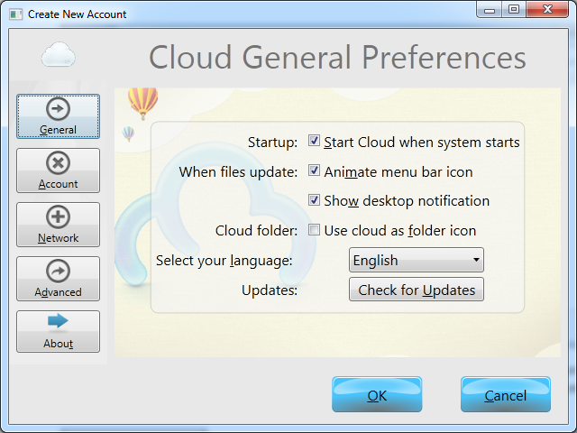

The Preferences page consists of an outer chrome with an inner Frame. The buttons down the left navigate the inner Frames. The OK and Cancel buttons belong to the outer chrome and control the overall acceptance or cancelling of any preference settings. Clicking the Check for Updates button will show the DialogCheckForUpdates window. Clicking OK at any point will save the settings. Clicking Cancel at any point will throw away changes. Either will animate this window back to the system tray.

Click the Account button to the the next Frame:

PagePreferences (outer chrome), FramePreferencesAccount (inner content):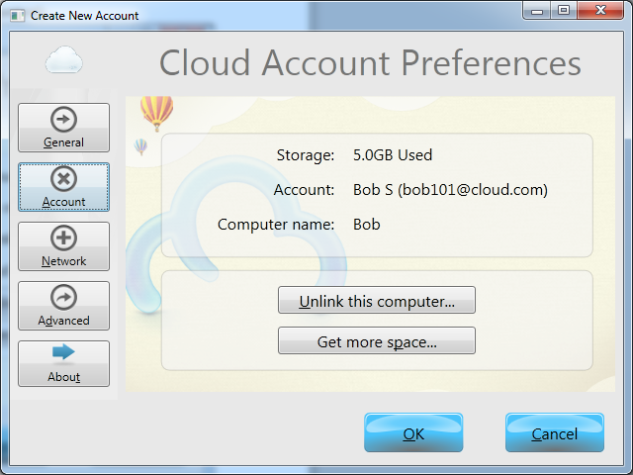

Click the Get more space to see an informational dialog:

MessageBox: Not Implemented: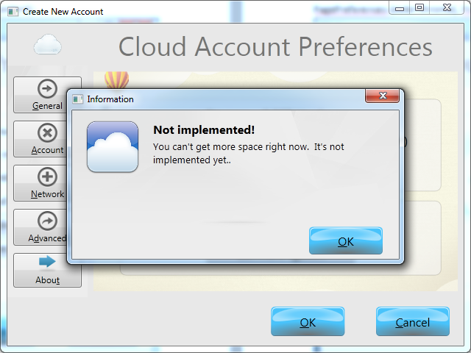

This is a modal dialog. The controls underneath are disabled. Click OK to dismiss the dialog and return to FramePreferencesAccount.

Click Unlink this Computer to see the following dialog:

MessageBox: Unlink this device?: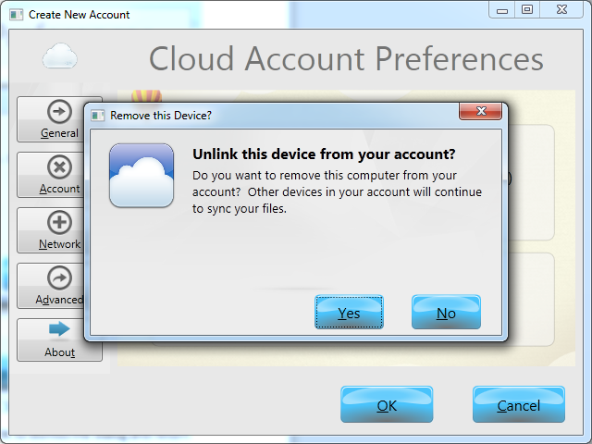

Click Yes to unlink this device from your account. This will immediately exit the Cloud app. Click No to return to FramePreferencesGeneral.

Click the Network button to see the next frame:

PagePreferences (outer chrome), FramePreferencesNetwork (inner content):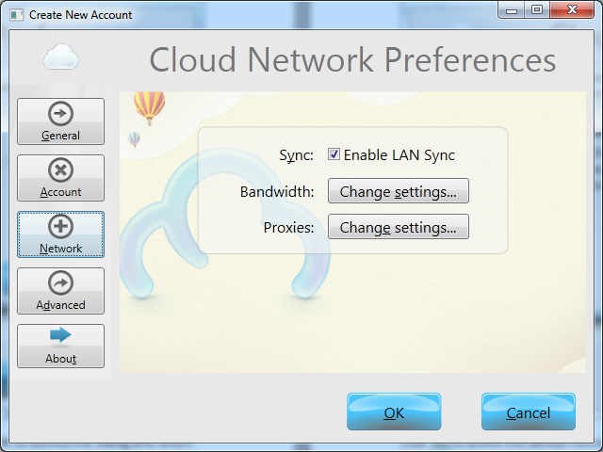

Click the “Bandwidth: Change Settings” button to see the next modal dialog.

DialogPreferencesNetworkBandwidth: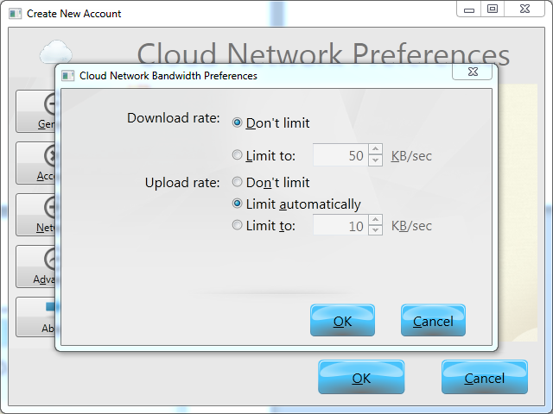

Click OK to save these changes. Note that clicking Cancel on the outer window will discard the changes. Click Cancel to discard the changes. Either button will exit the modal dialog back to FramePreferencesNetwork.

Click the “Proxies: Change Settings…” button to show the next frame:

DialogPreferencesNetworkProxies: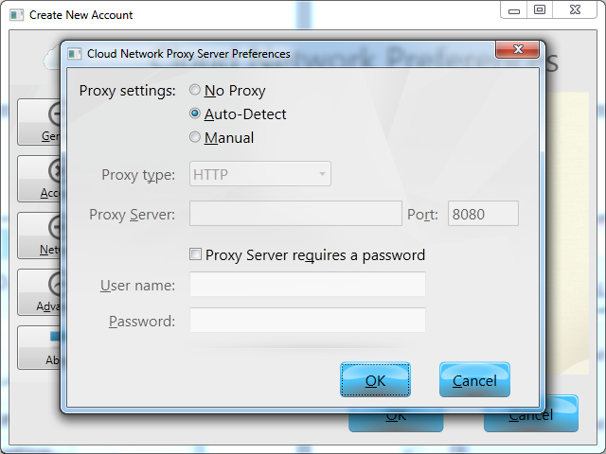

Click OK to save these changes. Note that clicking Cancel on the outer window will discard the changes. Click Cancel to discard the changes. Either button will exit the modal dialog back to FramePreferencesNetwork.

Click the Advanced button to show the next page:

PagePreferences (outer chrome), FramePreferencesAdvanced (inner content):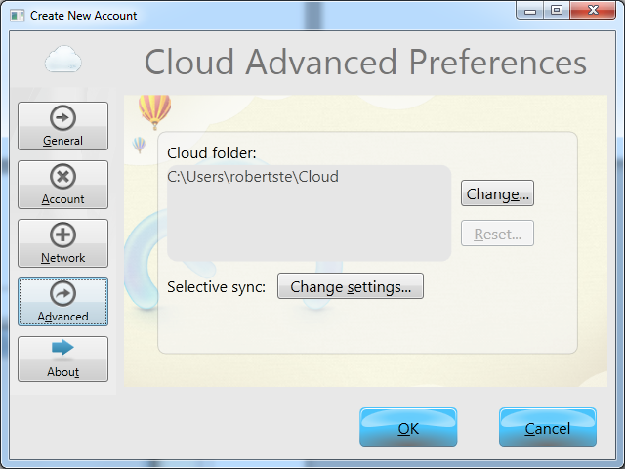

Click the “Selective sync: Change Settings..” button to see the next modal dialog:

MessageBox: Not Implemented: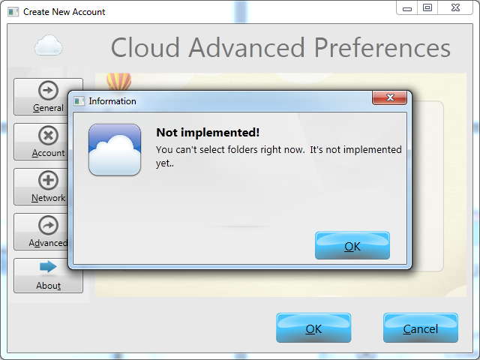

Click OK to return to FramePreferencesAdvanced. The Change and Reset buttons function as described before for PageFolderSelection.

Click the About button to see the next page:

PagePreferences (outer chrome), FramePreferencesAbout (inner content):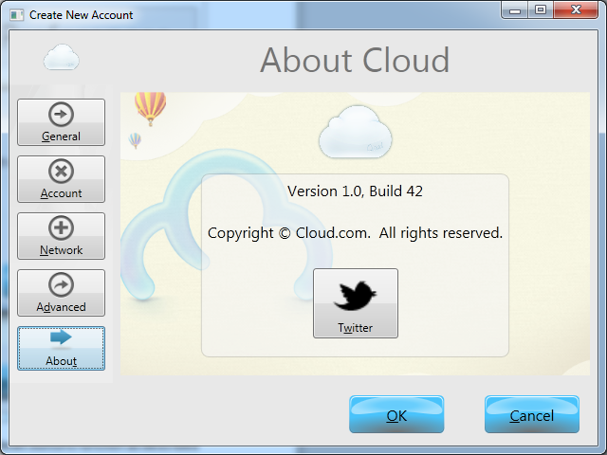

Click the Twitter button to launch the default browser in a separate window and navigate to the Twitter Cloud.com page.

Click the PagePreferences OK or Cancel button to save or cancel your changes, respectively. Either button will exit this window and animate back to the system tray.

If you have made changes and click the Cancel button, you will be prompted for whether you want to save those changes as in the following modal dialog:

MessgageBox: Save your changes?: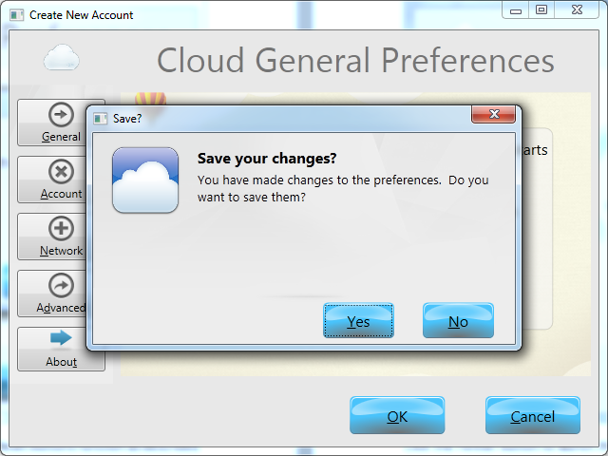

Clicking Yes will save the changes. Clicking No will discard them. In either case the PagePreferences window will disappear and animate to the system tray.

Now remove cloud directory and rerun the app. You will see the following window:

PageCloudFolderMissing: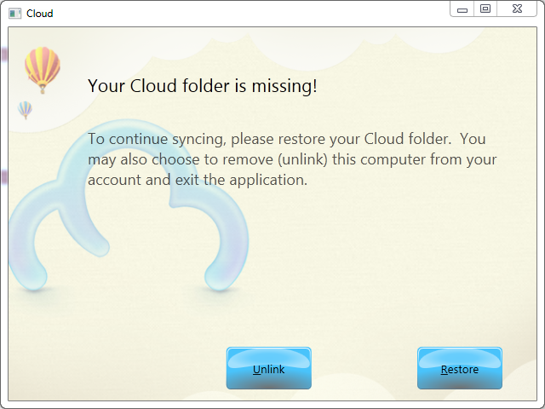

Click Unlink, and Cloud exits.

Run the program again and it is a new start, just like a new user would see starting from scratch:

PageHome: